Name: | Date:
Graded Assignment Physics A
Semester Test, Part 2
This is a test! No other resources are to be used other than the equation sheet provided in the student resources and a calculator! Show all work for each question, including initial equations before substituting values. Your final answer must be clearly marked with proper units
(31 points total, 4 questions)
(8 points)
- Find the speed and velocity of a racecar that completes 100 laps (100 complete times around) around a track with a circumference of 1.800 km in 30.0 minutes.
You must show all work and report your final answers with proper units (meters/second) and significant figures.
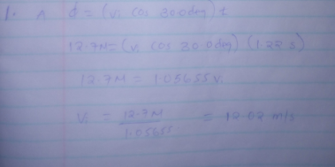
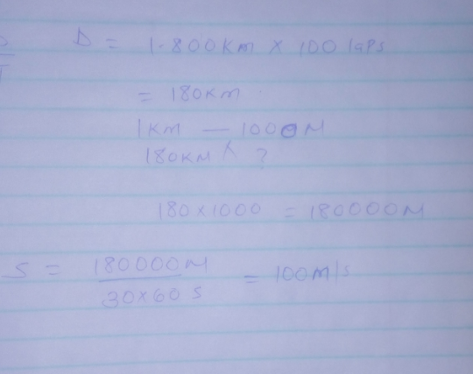

(8 points)
- A quarterback throws a pass down the field at an angle of 30.0 degrees. The ball is caught 12.7 meters downfield at the same height, 1.22 seconds after it is thrown. (image from The Science of NFL Football)
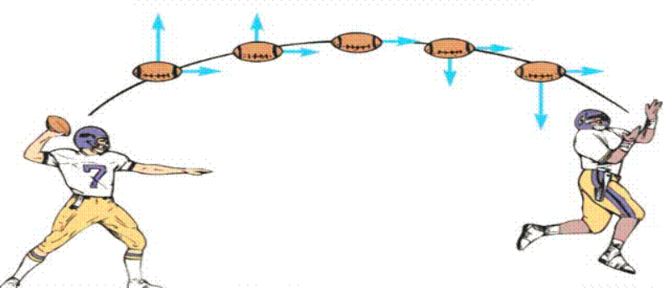
- Find the Initial velocity of the ball.

- What was the maximum height of the ball relative to the height of the initial throw?

- Find the velocity and angle of the ball as it is caught

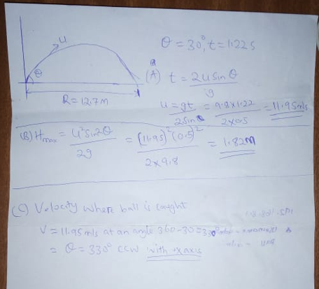

(8 points)
- Using Newton’s laws of motion and vectors, explain how to find the net force and net acceleration of an object experiencing forces perpendicular to each other. Provide an example problem and solution that would model your explanation. Include a free body (or force) diagram and show all work with your solution using proper units and significant figures.
An object at rest tends to stay at rest and objects at motion tends to stay in motion in the same speed and direction unless acted upon by an unbalanced force.
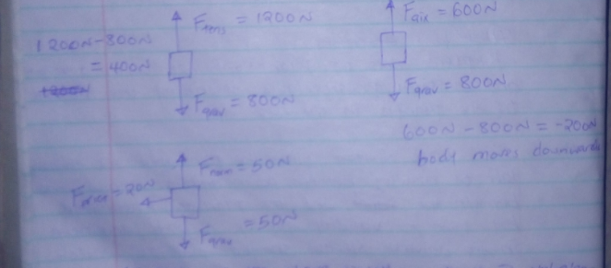
In the above situations, there’s an unbalanced force. It’s commonly said that in each situation their net force acting upon the object, the net force is the vector sum of all the forces acting upon the object. Downward vector will provide a full or partial concentration of the downward vector. Leftward vector will provide a full or partial concentration of rightward vector.
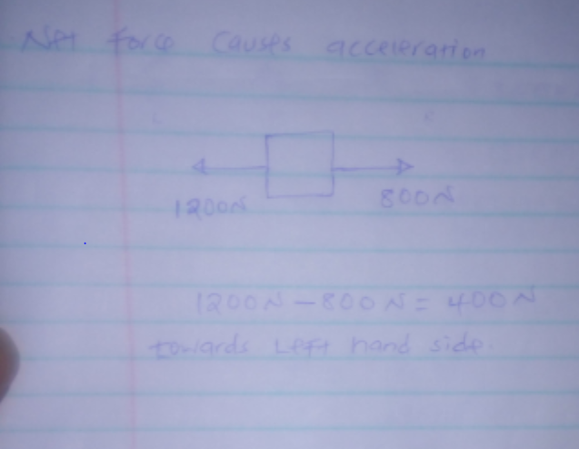

(7 points)
- A) Describe the significance of Kepler’s 3 laws of planetary motion. Be sure you include all three laws!
Keeper’s three laws of planetary motion can be stated as follows:
- All planets move about the Sun in elliptical orbits, having the Sun as one of the foci.
- A radius vector joining any planet to the Sun sweeps out equal areas in equal lengths of time.
- The squares of the sidereal periods (of revolution) of the planets are directly proportional to the cubes of their mean distances from the Sun.
- Name and describe the work of at least 2 other scientists who contributed to the theory of gravity which helped explain Kepler’s observations.
Sir Isaac Newton- when he formulated his well-known law of gravity between the Sun and the Planets, helped in postulating about all the objects in the universe. Newton stated that the motion of bodies subject to gravitational force doesn’t need to follow elliptical orbit which is specified by the first law of Keeper but can take path defined by the other, open conic curves; the motion can be hyperbolic or parabolic orbits, depending on the total energy of the body.
Edward Halley-spend most of his time explaining lunar but was also interested in matters concerning gravity. One problem that he was interested in was the proof of Keeper’s laws of planetary motion. He decided to discuss this matter with Isaac Newton in August 1684, only to find out that Newton had come up with the solution to the problem, at the investigation of Flamsteed with regard to the orbit of the Comet Kiren without publishing the solution.

